Lecture 9, September 21, 2010 (Key Points)

Geomorphology of river basins
Drainage basins (also called river basins, watersheds, catchments) designate a region of landscape that collects precipitation and generates river runoff. Infiltrated water in soil supports vegetation and recharges aquifers, precipitation and surface runoff erode sediments, flowing water overland and through the subsurface collects nutrients and biogeochemical variables, such as carbon and nitrogen.
Three characteristic scales can be identified in drainage basins as shown in Fig. 9.1. These are A) laboratory scale (hydrodynamic and Darcy) (~1 m), B) single hillslope-link scale (~10² m), C) watershed scale (~10³-10⁵ m). The three distinct spatial scales have corresponding time scales that are not given here. Most hydrologic parameters tend to be highly variable due to spatial variability in natural topography, soils and vegetation. Therefore, spatial variability in parameters in physical equations at the laboratory scale (hydrology has a huge literature at this scale) cannot be accounted for with the available data and existing theories/models at the scales of hillslopes and river basins (Review the discussion on spatial scale and parameterization in Brutsaert (2005, Sec. 1.4.3, Lecture 2, and our discussion on ET in Lectures 5 and 6). This foundational difficulty in engineering hydrology led to the widespread practice of calibrating physical parameters for solving practical hydrologic science and engineering problems. As a result of calibration, the physical parameters and equations lose their physical relevance at larger scales.
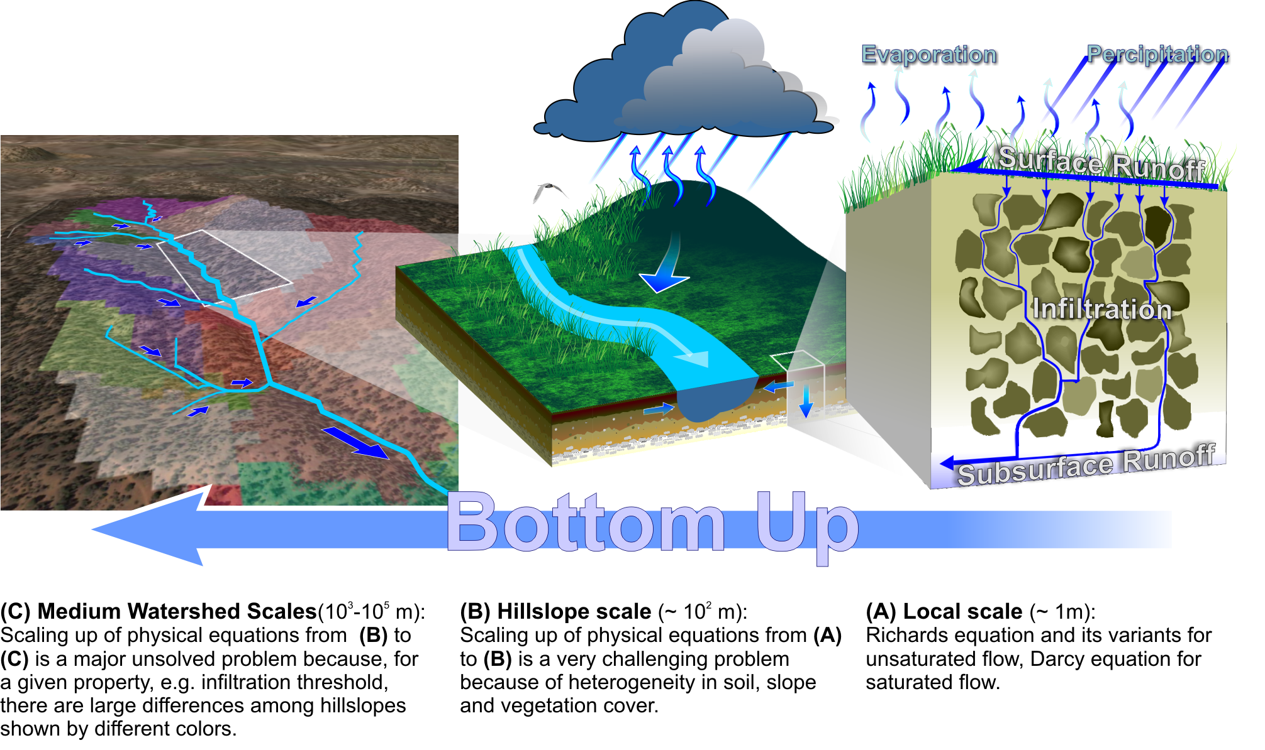

Figure-9.1. A schematic illustration of major challenges in scaling–up physical equations from the local scale to medium watershed scales

What physical equations are appropriate at the hydrodynamic scale?, hillslope-link scale?, watershed scales? At what spatial scale should hydrology in a river basin be conceptualized? These are key questions, and therefore they are areas of intense current research. To make progress in answering these questions, we turn to geomorphology of river basins.

9.1 Morphology of Drainage Basins
Basin morphology pertains to physical features of drainage basins. They are very briefly covered in Brutsaet (2005, pp. 9-10, chapters 11 and 12). That discussion is inadequate for our purposes. We need many more concepts than given there.
A river basin contains rivers that form a branching pattern called a river network, as illustrated in Fig. 9.2. It has a 'discrete and spatially variable’ branching structure on an otherwise 'continuous' landscape shown in Fig. 9.2. If we continue with the magnification, a branching pattern appears as shown for the Arroyo Caliente basin on the left hand side of Fig. 9.2. Where did we see a similar feature in previous lectures?
How can we compare two networks at different scales of resolution in terms of similarity in their 'topologic' or branching structure? Strahler ordering provides a solution.

Figure 9.2 A channel network at two different scales of resolution
(From Leopold and Miller, 1956)

9.2 Strahler Ordering
The Strahler ordering is defined by assigning an order, to the source streams, or the non-branched streams. When two streams of the same order ω meet, the downstream channel is assigned an order . When two streams of different order meet, the downstream channel carries the higher of the two orders. A complete Strahler stream of order ω consists of a chain of stream segments of order ω that is joined above by two streams of order and is joined below by a stream of order or by the basin outlet. Strahler ordering is schematically shown in Fig. 9.3.

Figure 9.3 An Ideal channel network showing Strahler ordering
(Melton,1959)

Strahler ordering has a unique property that if lower order streams are pruned away, the remaining higher order streams are not affected. They can be simply relabeled after pruning. For example, if streams of orders 1 and 2 are pruned away, then an order 3 stream becomes order 1, an order 4 stream becomes order 2 and so on. This establishes a one-to-one mapping between two networks of same size at different resolutions. In other words, a network at different map resolutions can be made 'topologically equivalent' in terms of their branching structure by simply pruning away the lower order streams from that network which has the higher order of the two. This important property is shown on the left hand side Fig.-9.4 below.

1
1
1
1
1
1
1
1
1
1
2
2
2
2
1
2
2
2
2
3

2
2
1

⇒
1
⇒

3
2

Figure 9.4 Properties of networks under pruning using Strahler order

Of the many classification schemes, which have been proposed for enumerating the branching structure, or the topologic structure, of networks (Zavoianu, 1985), none seem to exhibit the property of topologic equivalence under pruning. For example, consider “link magnitude”. It is defined as the total number of source streams that drain into a link. It violates a one-to-one mapping between two networks of same size at different resolutions, i.e., before and after pruning, as shown in the class. It is shown on the right hand side in the figure above. Melton’s paper cited in Fig. 9.3 also gives a proof but we will not get into this detail.
Strahler ordering led to the discovery of empirical Horton laws across multiple spatial scales of a branched network over fifty years ago. Current research has led to the hypothesis that Horton law can be extended to floods, which is example 4 mentioned in lecture 16.

9.4 Horton Laws
Strahler ordering led to the discovery, over fifty years ago, of empirical Horton laws.

- Let denote the total number of streams of order in a network of order . Then the Horton ratio of stream numbers can be written as,

(9.1)

where is known as the bifurcation ratio. Two streams of order form a stream of order 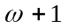. Therefore, . However, there is no upper limit to how large can be. Surprisingly, observations show that is tightly squeezed between 3 and 5 in most drainage networks.

- Observations indicate that, on average, does not change as increases in a basin of order . This observation is the Horton law of stream numbers which can be written as equation (9.1) with the added condition that remains invariant with a change in .

- For data analysis, we can use eq. (9.1) recursively to obtain the number of streams of order in terms of as,

(9.2)

- We can deduce some simple implications from eq. (9.2). It shows that the number of streams grows in a geometric progression. Therefore, a relatively small difference in the value of can make a big difference in the total number of source streams. This difference becomes more exaggerated as the size of drainage area increases. For example, a network has only one trunk stream of order , and has first order or source streams. In two basins, both of order =5, one with and the other with = 4.5 gives and 410 respectively. However, in two basins of order 8 with the same bifurcation ratios as above, one obtains and 37,367 respectively.

- One can test the validity of the law of stream numbers from data in a preliminary manner by taking of eq. (9.2) and plotting versus as,

(9.3)

- Statistical regression analysis (covered in CVEN 3227 and in chapter 3 of your textbook) can be used to test how well this equation holds. The bifurcation ratio can be computed from the slope by comparing eq. (9.3) with eq. (9.2), which gives, . An example using real data is given in item 9.

- There is also a Horton law of drainage areas and a Horton law of stream lengths. These are, respectively,

(9.4)

(9.5)

where E denotes statistical mean or expectation, is the area ratio, and is the stream length ratio. These ratios capture geometric properties rather than topologic ones.

- Notice that Horton ratios are defined so that their value exceeds 1. So, in (9.4) and (9.5), the subscript for the numerator is and for the denominator is . Subscripts are opposite of this in Eq. (9.1). Why?

  - Examples using data

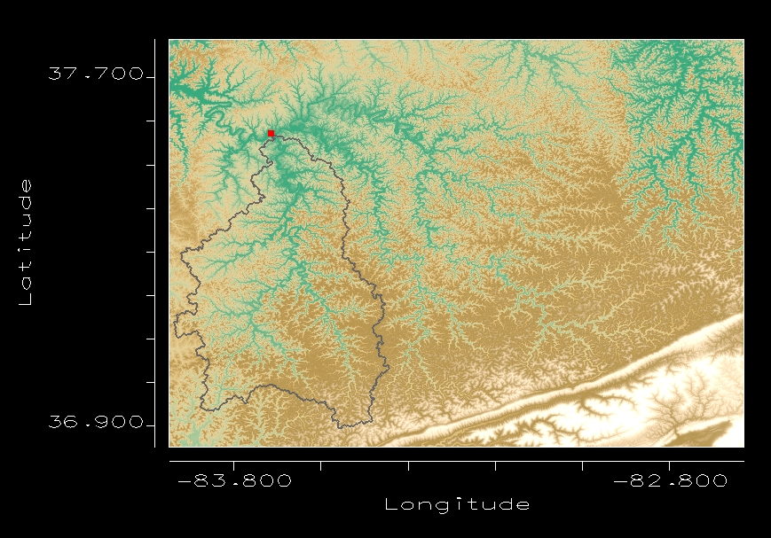

Figure 9.5 DEM image of the South Fork Kentucky River basin, KY
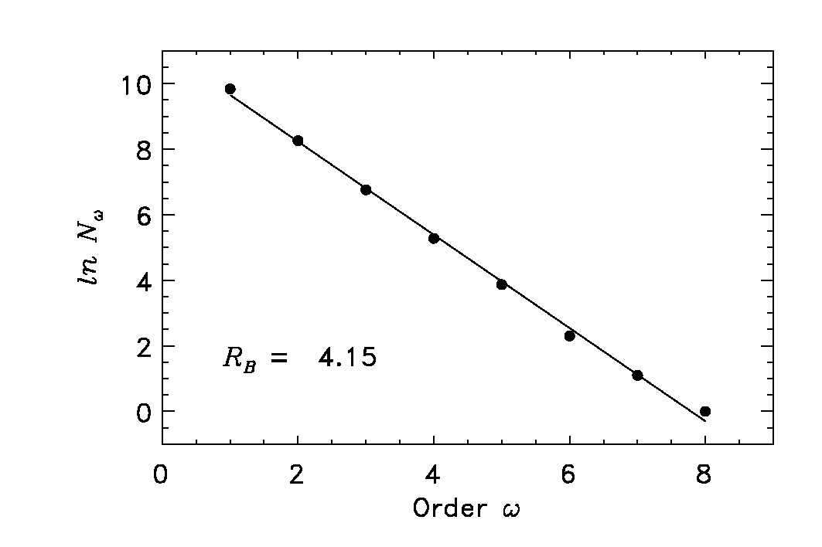
Figure 9.6 Horton law of stream numbers
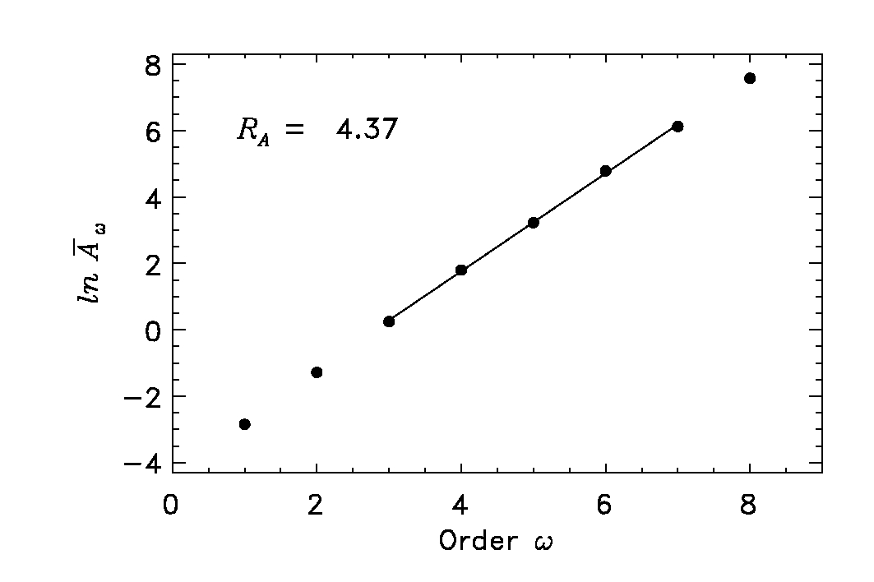
Figure 9.7 Horton law of mean drainage areas

Statistical Fluctuations in Drainage Areas

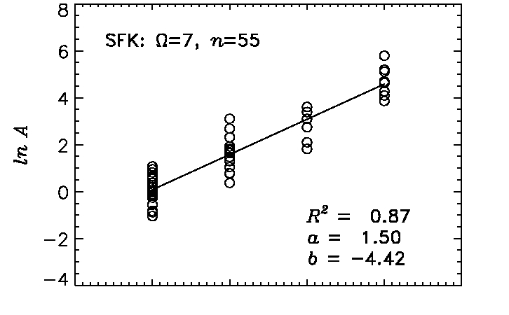
Order w

Figure 9.8 Horton law of mean drainage areas showing all points
(not just means)

References

Leopold, L. B. and J. P. Miller, USGS Prof. paper 282-A, 1956
Melton, J. Geology, 67: 345-6, 1959

